For office use only: Check______________________ CC________ Directory________ Update________ Web________
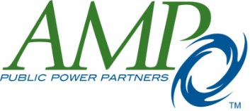

2016-17 Municipal Electric Partner Application

The Municipal Electric Partner (MEP) program runs July 1 – June 30 each year. Cost to participate in the MEP program is $425 (paid by credit card or check payable to AMP). To begin or continue your partnership for 2016-17, please complete the form below and return it to Jodi Allalen by email at jallalen@amppartners.org or U.S. Mail at AMP, Attn: Jodi Allalen, 1111 Schrock Rd., Suite 100, Columbus, OH 43229. We also invite you to send one of your sales brochures and/or an annual report for our files. All new MEP applications will be reviewed by AMP management who reserves the right to approve or deny any application. If you have any questions, please contact Jodi Allalen at 614.540.0916 or jallalen@amppartners.org.

Date

Company’s full name
Address
City State Zip
Phone Fax
Web site address

Contact Person
*The contact person will receive information from AMP (directory, mailings) at the above address.

Title
Phone Email
Person completing this form (if different from contact person)
Title
Phone Email

Description of your company’s products/services

Does your company provide speakers? Yes No
Would you like a link from our MEP web page to your web site? Yes No
Would you like to receive our weekly Update publication? Yes No
If yes, please provide the name(s) and e-mail address(es) you would like Update emailed to:

