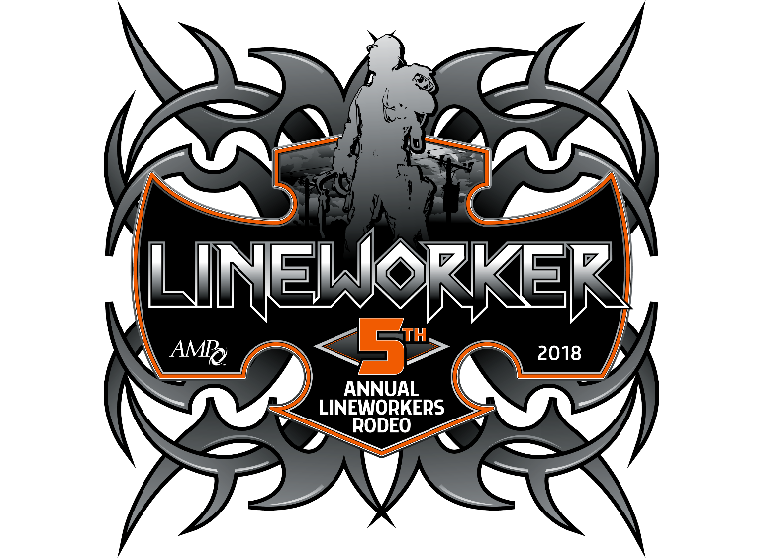

VENDOR SPONSORSHIP OPPORTUNITIES
MP LINEWORKERS RODEO
AUGUST 24 & 25

SPONSORSHIP OPPORTUNITIES

☐ Platinum MEP ☐ $2,000
- Space at Rodeo Vendor Expo during Registration (Friday, August 24)
- Space at rodeo competition (Saturday, August 25)
Please provide the size of tent you’ll be bringing _______________________FT
- Vendor can provide sign to display at Rodeo competition* (signs must be no larger than 4’x10’)
- Banquet tickets for 4 people (Saturday, August 25)
- Recognition as being a Platinum sponsor at the rodeo, banquet and in rodeo brochure
- Vendor name on sleeve of rodeo t-shirt – due date for vendor name on sleeve: July 27
- 2 official AMP Rodeo T-Shirts
Shirt Size (Please check one) ☐ Small ☐ Medium ☐ Large ☐ XL ☐ 2X ☐ 3XL ☐ 4XL
Shirt Size (Please check one) ☐ Small ☐ Medium ☐ Large ☐ XL ☐ 2X ☐ 3XL ☐ 4XL

☐ Gold MEP ☐ $1,000
- Space at Rodeo Vendor Expo during Registration (Friday, August 24)
- Space at rodeo competition (Saturday, August 25)
Please provide the size of tent you’ll be bringing: _______________________FT
- Vendor can provide sign to display at rodeo competition* (signs must be no larger than 4’x10’)
- Banquet tickets for 2 people (Saturday, August 25)
- Recognition as being a Gold sponsor at rodeo, banquet and in rodeo brochure
- Shirt Size (Please check one) ☐ Small ☐ Medium ☐ Large ☐ XL ☐ 2X ☐ 3XL ☐ 4XL

☐ Silver MEP ☐ $500
- Space at Rodeo Vendor Expo During Registration (Friday, August 24)
- Space at rodeo competition (Saturday, August 25)
Please provide the size of tent you’ll be bringing: _______________________FT
- Vendor can provide sign to display at rodeo competition* (signs must be no larger than 4’x10’)
- Recognition as being a Silver sponsor at rodeo, banquet and in rodeo brochure

☐ Bronze MEP ☐ $100
- Recognition as being a Bronze sponsor at rodeo, banquet and in rodeo Brochure
- Vendor can provide sign to display at rodeo competition* (signs must be no larger than 4’x10’)

☐ Sponsor a Rodeo Event (8 available) MEP ☐ $100
Events will be on a first come, first choice basis.
Available Events: (1) Hurtman Rescue, (2) Three Phase Transfer 4kV, (3) Wire Down, (4) Crossarm Change-Out, (5) Obstacle Course, (6) Rope Toss, (7) Insulator Change-Out, (8)Cut-Out Change-Out , (9)

1st Choice _______________________________________________ 2nd Choice ___________________________________________________
- Sponsorship for the rodeo event you select at the competition on Saturday.
- Opportunity to display sign at or near your sponsored event (signs must be no larger than 4’x10’)
* Display signs are responsibility of vendor
Vendors wanting to donate door prizes or material items needed for the rodeo such as poles please contact:
Jennifer Flockerzie at jflockerzie@amppartners.org ,614-540-0853
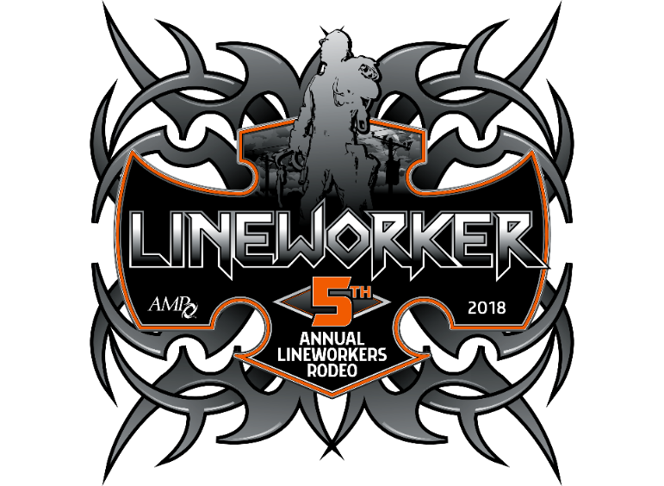
VENDOR SPONSORSHIP OPPORTUNITIES
AMP LINEWORKERS RODEO
AUGUST 24 &25

REGISTRATION: MEP

☐ Rodeo Competition Vendor Expo ☐ $150

Check day(s) attending
- ☐ Space at Rodeo Vendor Expo during Registration (Friday, August 24th)
- ☐ Space at rodeo competition (Saturday, August 25th)
Please provide the size of tent you’ll be bringing _______________________FT
☐ ADULT Banquet Only (per person) (Saturday, August 25) ☐ $55
☐ CHILD Banquet Only (per person) Children under 12 Free ☐ $16
Number of Adults _________
Number of Children)___________
TOTAL = $_______________
Rodeo Contact: Jennifer Flockerzie at jflockerzie@amppartners.org , 614-540-0853
NOTE: (Please print clearly.)The individual listed below will be the point of contact for all vendor rodeo-related matters. This individual does not have to attend the Rodeo in order to serve as the main contact for the vendor. This individual will be contacted with any questions from AMP and will receive the registration confirmation and all Rodeo-specific information such as changes to event specifications, maps, etc.

Company_____________________________________________________________________________________________________________________________________

Name Title

Address City State Zip

Phone Fax Email

Emergency Contact Phone Mobile Phone
Additional Attendees:
Name Title

Name Title
Attach additional sheets with attendees, names and titles if needed
TENT/TRAILER INFORMATION
☐ Will bring Tent / Trailer (Circle one) Dimension ____________________________________________________________________________________

PAYMENT INFORMATION
PAYMENT METHOD: All fees payable in U.S. currency. Please check () the appropriate box:
☐ Enclosed is my check made payable to: American Municipal Power
☐ Please charge the following credit card: ☐ MasterCard ☐ VISA ☐ American Express ☐ Discover
Name as it Appears on Card________________________________________________ Name of Main Contact__________________________________________________
Credit Card Number_______________________________________________________ Expiration Date _______________________________________________________
Amount to Charge to Card $______________ Cardholder Signature _________________________________
CONFIRMATIONS — Please send my confirmation via ☐ Mail or ☐ Email to: _______________________________________________________________________
TRAVEL — Travel arrangements and costs are the responsibility of the participants. AMP will not reimburse for changes in travel expenditures regardless of the cause, including the cancellation of event.
HOTEL— Rooms are available at the Crowne Plaza North, 6500 Doubletree Ave., Columbus, Ohio, for the discounted rate of $100/night (includes breakfast for one person per room in the restaurant) plus applicable taxes.. A block of rooms has been reserved for the nights of Aug. 24-25. Please contact the Crowne Plaza directly at 614-885-1885 and ask for the “American Municipal Power Rate.”
CANCELLATIONS — All cancellations must be submitted in writing before Aug. 17to be entitled to a refund, minus a $50 cancellation fee. No-shows who do not cancel before Aug 17 are responsible for entire registration/sponsorship fee. All cancellations must be made in writing and mailed, faxed, or emailed to: American Municipal Power, 1111 Schrock Road, Suite 100, Columbus, Ohio 43229 - Attention: Jennifer Flockerzie, fax: 614-540-6929, email: rodeo@amppartners.org.
PHOTOGRAPHS — By registering for this Rodeo, I authorize American Municipal Power (AMP) to photograph me at this event and use such photographs in AMP marketing and other communications (both electronic and print). I understand that I will not be paid for giving this consent.
Attention: Jennifer Flockerzie • Fax: 614-540-6929 • email: rodeo@amppartners.org

