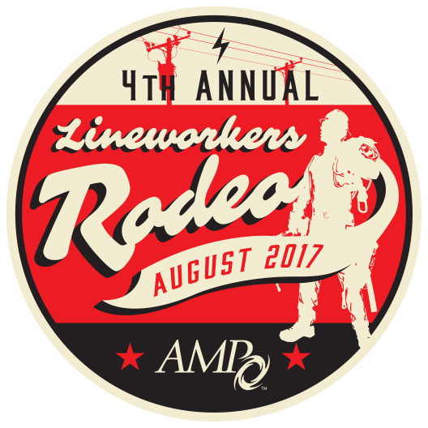

REGISTRATION DEADLINE

AUGUST 11
BANQUET TICKET/PACKET/T-SHIRT FORM

Crowne Plaza – Columbus North, 6500 Doubletree Ave., Columbus, Ohio 43229
Rodeo Contact: Jennifer Flockerzie at rodeo@amppartners.org, 614-540-0853
NOTE: All guest packets will be available at AMP Headquarters under the purchaser’s name. Pick up will be from 10:00 a.m. to 3:00 p.m. on Friday, Aug. 25. Any packets not picked up will be available at the rodeo grounds at the information/sales tent on Saturday, Aug. 26.

Purchaser Name Utility

Address City State Zip

Phone Fax Email
.
Guest Packet Pricing
OPTION | Guest Packet Description | Before August 11 | After August 11
1 | One Adult Banquet Ticket and Short-Sleeved T-shirt (Small-3X) | $55 | $80
2 | Adult T-Shirt Only | $15 | $25
3 | Adult Banquet Ticket Only | $45 | $55
4 | One Child Banquet Ticket and Short-Sleeved T-Shirt (Small-Large) | $26 | $46
5 | Child T-Shirt Only | $10 | $20
6 | One Child Banquet Ticket Only (Children under 12 Free) | $15 | $26

Guest Packet Order
OPTION | Quantity | T-Shirt Size(s) put desired quantity under size |  |  |  |  |  |  | COST
#1 – One ADULT Banquet Ticket & Short-Sleeved T-Shirt |  | S | M |  | L | XL | 2X | 3X
#2 ADULT T-Shirt Only |  | S | M |  | L | XL | 2X | 3X
#3 ADULT Banquet Ticket ONLY
#4 CHILD Banquet Ticket & Child Short-Sleeved T-Shirt |  | Youth XS |  | Youth S |  | Youth M | Youth L
#5 CHILD T-SHIRT Only |  | Youth XS |  | Youth S |  | Youth M | Youth L
#6 CHILD Banquet Ticket ONLY
TOTAL
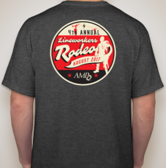
2017 Rodeo T-Shirt
A limited number of t-shirts will be available for sale the day of rodeo. Shirt color may vary.

PAYMENT METHOD: All fees payable in U.S. currency. Please check () the appropriate box:
Enclosed is my check made payable to: American Municipal Power Bill me (AMP MEMBERS ONLY) Purchase Order # (Optional) ____________
Please charge the following credit card: MasterCard VISA American Express Discover
Name as It Appears on Card ________________________________________________ Name of Main Contact__________________________________________________
Credit Card Number _______________________________________________________ Expiration Date _______________________________________________________
Amount to Charge to Card $______________ Cardholder Signature _________________________________
Mail completed form and full payment to:
CONFIRMATIONS — Please send my confirmation via Mail or Email to: _______________________________________________________________________
TRAVEL — Travel arrangements and costs are the responsibility of the participants. AMP will not reimburse for changes in travel expenditures regardless of the cause, including the cancellation of event.
HOTEL— Rooms are available at the Crowne Plaza North, 6500 Doubletree Ave., Columbus, Ohio, for the discounted rate of $98/night (includes breakfast for one person per room in the restaurant) plus applicable taxes. A block of rooms has been reserved for the nights of Aug. 24-26. Please contact the Crowne Plaza directly at 614-885-1885 and ask for the “American Municipal Power Rate” **AMP Rate subject to Change**
CANCELLATIONS — All cancellations must be submitted in writing before Aug 11 to be entitled to a refund of the entry fees, minus a $30 cancellation fee. No-shows who do not cancel before Aug 12 are responsible for the full fees and are not entitled to a refund. Cancellation must be made in writing and mailed, faxed, or emailed to: American Municipal Power, 1111 Schrock Road, Suite 100, Columbus, Ohio 43229 - Attention: Jennifer Flockerzie, fax: 614-540-6929, email: rodeo@amppartners.org.
PHOTOGRAPHS — By registering for this Rodeo, I authorize American Municipal Power (AMP) to photograph me at this event and use such photographs in AMP marketing and other communications (both electronic and print). I understand that I will not be paid for giving this consent.
American Municipal Power, 1111 Schrock Road, Suite 100, Columbus, Ohio 43229 ATTENTION: Jennifer Flockerzie-AMP RODEO Fax: 614-540-6929 • email: rodeo@amppartners.org

