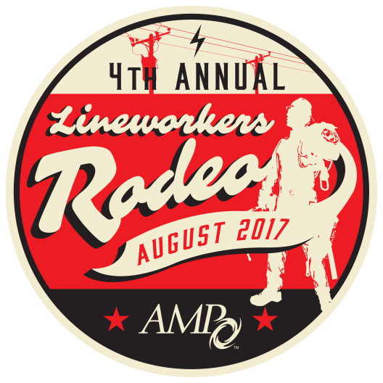

AMP LINEWORKERS RODEO

AUGUST 26
VOLUNTEER REGISTRATION FORM

Rodeo Contact: Jennifer Flockerzie at rodeo@amppartners.org, 614-540-0853
NOTE: (Please print clearly)

Utility________________________________________________________________________________________________________________________________________

Name Title

Address City State Zip

Phone Fax Email

Emergency Contact Phone Mobile Phone

Check here if you have a disability and may require special accommodations to participate.

MEMBER VOLUNTEER REGISTRATION (Check all that apply)

☐ Greeter/Auditor Volunteer ☐ Information/Sales Tent ☐ Floater ☐ Other (No preference)
(Sat. 8/26 All day) (Sat. 8/26 All day) (Sat. 8/26 All day) (Sat. 8/26 All day)

☐ Apprentice Judge (Experience required) ☐ Journeyman Judge (Experience required) ☐ Judge (No preference) (Experience required)
(Sat. 8/26 All day) (Sat. 8/26 All day) (Sat. 8/26 All day)

List experience here to be considered for a judging position:

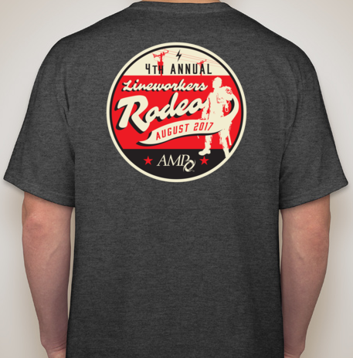
Volunteers will receive a complimentary Rodeo short-sleeved t-shirt, ticket for lunch during competition, and a ticket to the awards dinner banquet.
Shirt Size (Please check one) ☐ Small ☐ Medium ☐ Large ☐ XL ☐ 2X ☐ 3XL ☐ 4XL
☐ Will Be Attending Banquet ☐ Will NOT Be Attending Banquet

Send completed form to:
American Municipal Power, 1111 Schrock Road, Suite 100, Columbus, Ohio 43229
ATTENTION: Jennifer Flockerzie-AMP RODEO
Fax: 614-540-6929 • email: rodeo@amppartners.org
CONFIRMATIONS — Please send my confirmation via ☐ Mail or ☐ E-mail to: _______________________________________________________________________
TRAVEL — Travel arrangements and costs are the responsibility of the participants. AMP will not reimburse for changes in travel expenditures regardless of the cause, including the cancellation of a training session.
HOTEL— Rooms are available at the Crowne Plaza North, 6500 Doubletree Ave., Columbus, Ohio, for the discounted rate of $98/night (includes breakfast for one person per room in the restaurant) plus applicable taxes. A block of rooms has been reserved for the nights of Aug. 24-26. Please contact the Crowne Plaza directly at 614-885-1885 and ask for the “American Municipal Power Rate.”
PHOTOGRAPHS — By registering for this Rodeo, I authorize the American Municipal Power (AMP) to photograph me at this event and use such photographs in AMP marketing pieces (both electronic and print). I understand that I will not be paid for giving this consent.
WAIVER — Each volunteer will be required to sign a liability waiver before beginning volunteer activities.

