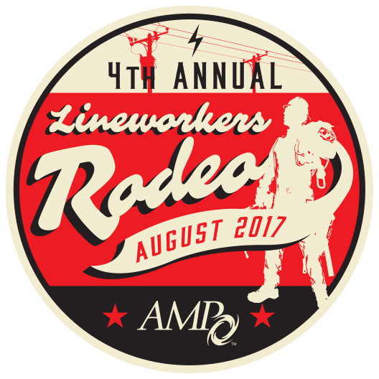

AMP LINEWORKERS RODEO

AUGUST 25 & 26
CONTESTANT & TRAINING REGISTRATION

Rodeo Contact: Jennifer Flockerzie at jflockerzie@amppartners.org, or 614-540-0853
NOTE: (Please print clearly.)
The individual listed below will be the point of contact for all utility Rodeo-related matters. This individual does not have to attend the Rodeo in order to serve as the main contact for the utility. This individual will be contacted with any questions from AMP and will receive the registration confirmation and all Rodeo-specific information such as changes to event specifications, maps, etc.

Utility________________________________________________________________________________________________________________________________________

Name Title

Address City State Zip

Phone Fax Email

Emergency Contact Phone Mobile Phone

☐ Check here if you have a disability and may require special accommodations to participate.
TENT/TRAILER INFORMATION
☐ Will bring Tent / Trailer (Circle one) Dimensions: __________________________________________________________________________________

Entry Fees: Payment and forms must be received by July 28, to take advantage of early pricing discount.

COMPETITOR REGISTRATION (Check all that apply)
Received On/Before July 28 After July 28 Quantity Total
(Deadline August 4)
 | $
 | $
 | $
 | $
Total A | $

☐ Team bringing a Judge ☐ $300 (each)* ☐ $350 (each) *
☐ Team not bringing a Judge ☐ $350 (each)* ☐ $400 (each)*
☐ Journeyman ☐ $150 (each)* ☐ $200 (each)*
☐ Apprentice ☐ $150 (each)* ☐ $200 (each)*
(*Please enter competitor’s information on page 3)

Individuals from multiple member communities may combine employees to form a team

TRAINING COURSE REGISTRATION (Check all that apply)
 | $
 | $
Total B | $

☐ Dangers of Backfeed in Overhead Linework ☐ No Cost (Registration Required)
(Fri. Aug. 26, 9:00 – 10:00 a.m.)
☐ Metering Safety ☐ No Cost (Registration Required)
(Fri. Aug. 26, 10:30 - 11:30 a.m.)

Participation in Rodeo not necessary to attend training courses.

GRAND TOTAL (A&B) ____________________

OPEN TO AMP MEMBERS ONLY
To qualify for candidacy for AMP Sponsorship to the APPA Rodeo in 2018, members must compete in the AMP Rodeo in 2017

REGISTRATION DEADLINE
CONTESTANT & TRAINING REGISTRATION

AUGUST 4

ENTRY FEE FORM

PAYMENT METHOD: All fees payable in U.S. currency. Please check () the appropriate box:

☐ Enclosed is my check made payable to: American Municipal Power
☐ Invoice me ☐ Purchase Order # (Optional) _________________
☐ Please charge the following credit card: ☐ MasterCard ☐ VISA ☐ American Express ☐ Discover

Name as It Appears on Card________________________________________________ Name of Main Contact__________________________________________________

Credit Card Number_______________________________________________________ Expiration Date _______________________________________________________

Amount to Charge to Card $____________________________ Cardholder Signature __________________________________
Send completed form to:
American Municipal Power, 1111 Schrock Road, Suite 100, Columbus, Ohio 43229
ATTENTION: Jennifer Flockerzie-AMP RODEO
Fax: 614-540-6929 • email: jflockerzie@amppartners.org
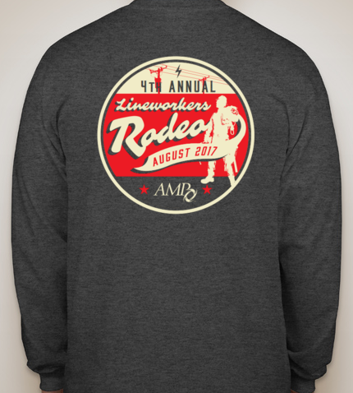

Contestants will receive a complimentary long-sleeved, dark grey Rodeo t-shirt, one (1) ticket for lunch during competition and one (1) ticket to the Awards Banquet.
CONFIRMATIONS — Please send my confirmation via Mail or E-mail to: _______________________________________________________________________
TRAVEL — Travel arrangements and costs are the responsibility of the participants. AMP will not reimburse for changes in travel expenditures regardless of the cause, including the cancellation of a training session.
HOTEL— Rooms are available at the Crowne Plaza North, 6500 Doubletree Ave., Columbus, Ohio, for the discounted rate of $98/night (includes breakfast for one person per room in the restaurant) plus applicable taxes. A block of rooms has been reserved for the nights of Aug. 24-26. Please contact the Crowne Plaza directly at 614-885-1885 and ask for the “American Municipal Power Rate” **AMP Rate subject to Change**.
CANCELLATIONS — All cancellations of team or apprentice participation must be submitted in writing before Aug. 4 to be entitled to a refund of the entry fees, minus a $50 cancellation fee. Teams or apprentices who cancel after Aug 11 will not receive a refund, but substitutions will be allowed for this event only. Teams, apprentices, and no-shows who do not cancel before Aug 11 are responsible for the full entry fees and are not entitled to a refund. Cancellation must be made in writing and mailed, faxed, or emailed to: American Municipal Power, 1111 Schrock Road, Suite 100, Columbus, Ohio 43229 - Attention: Jennifer Flockerzie, fax: 614-540-6929, email: jflockerzie@amppartners.org.
PHOTOGRAPHS — By registering for this Rodeo, I authorize American Municipal Power (AMP) to photograph me at this event and use such photographs in AMP marketing and other communications (both electronic and print). I understand that I will not be paid for giving this consent.
WAIVER — Each competitor will be required to sign a liability waiver before he or she begins participating in the training course or rodeo.

Attention: Jennifer Flockerzie • Fax: 614-540-6929 • email: jflockerzie@amppartners.org

REGISTRATION DEADLINE
CONTESTANT & TRAINING REGISTRATION

AUGUST 4

Please include additional copies of this form if registering more than one team.

Utility Name______________________________________________________________State___________________

TEAM | First Name | Last Name | T-Shirt Size all shirts are long sleeve,  S - 4X | Will be Attending Banquet | Sign in the space below to attest to the following statement: I understand that all hooks, belts and tools furnished by me will be in a safe operating condition
Lineworker #1
Lineworker # 2
Groundworker
Alternate
THE FOLLOWING MUST BE COMPLETED BY JOURNEYMAN’S SUPERVISOR:
I certify that the personnel named above are journeymen lineworkers, and that they are qualified to climb electric utility poles.

Supervisor’s Name_______________________________________ Signature________________________________

Apprentice | First Name | Last Name | T-Shirt Size all shirts are long sleeve, S - 4X | Will be Attending Banquet | Sign in the space below to attest to the following statement: I understand that all hooks, belts and tools furnished by me will be in a safe operating condition
Apprentice
Apprentice
Apprentice
Apprentice
THE FOLLOWING MUST BE COMPLETED BY APPRENTICE’S SUPERVISOR:
I certify that the personnel named above are apprentice lineworkers, and that they are qualified to climb electric utility poles.

Supervisor’s Name_______________________________________ Signature________________________________

Individual Journeyman | First Name | Last Name | T-Shirt Size all shirts are long sleeve, S -4X | Will be Attending Banquet | Sign in the space below to attest to the following statement: I understand that all hooks, belts and tools furnished by me will be in a safe operating condition
Journeyman
Journeyman
Journeyman
Journeyman
THE FOLLOWING MUST BE COMPLETED BY JOURNEYMAN’S SUPERVISOR:
I certify that the personnel named above are journeymen lineworkers, and that they are qualified to climb electric utility poles.

Supervisor’s Name_______________________________________ Signature________________________________

**Each Participate will be required to sign a liability waiver before participating in the training course or rodeo

**Attention: Jennifer Flockerzie • Fax: 614-540-6929 • email: jflockerzie@amppartners.org

WANTED
COMPETITOR SHIRTS

AMP is framing the competitor t-shirts of those members participating in the AMP Lineworkers Rodeo. If you would like to contribute one of your competitor shirts to be framed and added to the rodeo wall, please bring an extra shirt to the rodeo or mail to:

American Municipal Power
Attn: Jennifer Flockerzie
1111 Schrock Road
Columbus, Ohio 43229

